**Project 2(a) Create and Populate Service Table Using SQL**

**Microsoft SQL Server Syntax 1**

**/*CREATE SERVICE TABLE ADDING PRIMARY KEY AND LOCAL ATTRIBUTES*/**

CREATE TABLE SERVICE

(   
Service_Id int NOT NULL,  
Service_Name varchar(255),  
PRIMARY KEY (Service_Id)  
);

**/*ALTER SERVICE TABLE ADDING FOREIGN KEY ATTRIBUTES*/**

ALTER TABLE SERVICE

ADD Contract_Id int FOREIGN KEY REFERENCES CONTRACT(Contract_Id)

ALTER TABLE SERVICE

ADD Consultant_Id int FOREIGN KEY REFERENCES CONSULTANT(Consultant_Id)

**/*POPULATE DATA INTO SERVICE TABLE*/**

INSERT INTO SERVICE VALUES (10, ‘Web Designer’, 10, 10);

INSERT INTO SERVICE VALUES (20, ‘Network Infrastructure’, 20, 20);

INSERT INTO SERVICE VALUES (30, ‘Software Engineer’, 30, 30);

INSERT INTO SERVICE VALUES (40, ‘Database Development’, 40, 40);

INSERT INTO SERVICE VALUES (50, ‘Ethical Hacking’, 50, 50);

INSERT INTO SERVICE VALUES (60, ‘Java Programming’, 60, 60);

INSERT INTO SERVICE VALUES (70, ‘PHP Programming’, 70, 70);

INSERT INTO SERVICE VALUES (80, ‘Network Security’, 80, 80);

INSERT INTO SERVICE VALUES (90, ‘Distributed Systems’, 90, 90);

**/*OUTPUT SERVICE TABLE*/**

SELECT * FROM SERVICE

**Output from above SQL Queries for SERVICE Table**

|  |  |  |  |
| --- | --- | --- | --- |
| **Service_Id** | **Service_Name** | **Consultant_Id** | **Contract_Id** |
| 10 | Web Designer | 10 | 10 |
| 20 | Network Infrastructure | 20 | 20 |
| 30 | Software Engineering | 30 | 30 |
| 40 | Database Development | 40 | 40 |
| 50 | Ethical Hacking | 50 | 50 |
| 60 | Java Programming | 60 | 60 |
| 70 | PHP Programming | 70 | 70 |
| 80 | Network Security | 80 | 80 |
| 90 | Distributed Systems | 90 | 90 |

**SCREENSHOT OF SQL QUERY AND SERVICE TABLE OUTPUT**

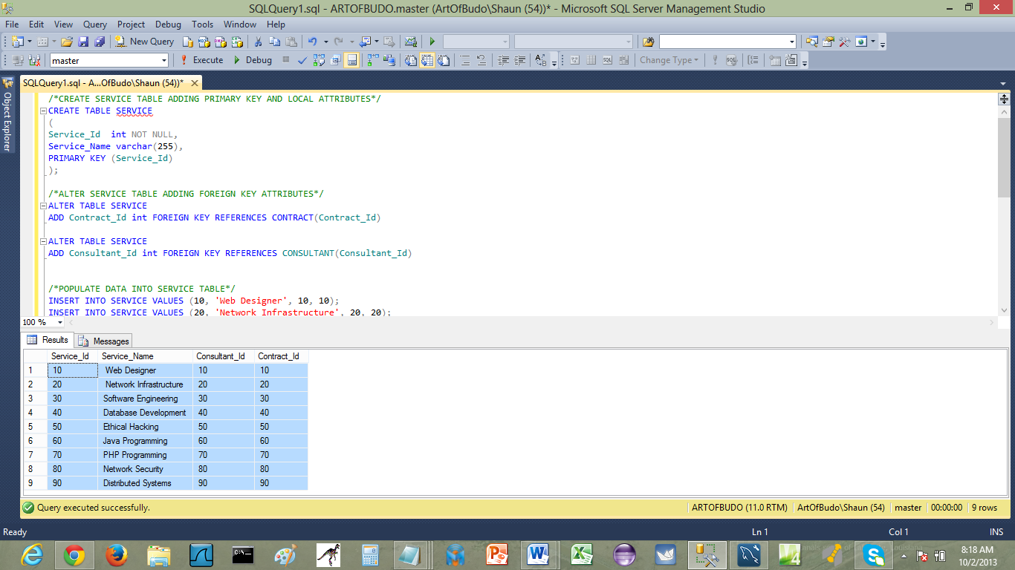

**Project 2(b) Select Consultants in a Given Region Using SQL1**

**/*OUTPUT CONSULTANT AND REGION TABLES*/**

SELECT * FROM CONSULTANT

SELECT * FROM REGION

**CONSULTANT TABLE**

|  |  |  |  |  |  |
| --- | --- | --- | --- | --- | --- |
| **Consultant_Id** | **Consultant_Last** | **Consultant_First** | **Consultant_Middle** | **Service_Id** | **Region_Id** |
| 10 | HANNAH | JARRETT | NULL | 10 | 10 |
| 20 | SAMMY | GALLAGHER | NULL | 20 | 20 |
| 30 | ROSEANN | THORPE | NULL | 30 | 30 |
| 40 | CHARMAINE | BRYAN | NULL | 40 | 40 |
| 50 | CATHI | PUCKETT | NULL | 50 | 50 |
| 60 | TYRON | HOLLINGSWORTH | NULL | 60 | 60 |
| 70 | LUPE | SANTANA | NULL | 70 | 70 |
| 80 | CATHI | WHITEHEAD | NULL | 80 | 80 |
| 90 | ABRAHAM | PLATT | NULL | 90 | 90 |

**REGION TABLE**

|  |  |  |  |
| --- | --- | --- | --- |
| **Region_Id** | **Region_Name** | **Client_Id** | **Consultant_Id** |
| 10 | North | 10 | 10 |
| 20 | South | 20 | 20 |
| 30 | East | 30 | 30 |
| 40 | West | 40 | 40 |
| 50 | NorthEast | 50 | 50 |
| 60 | NorthWest | 60 | 60 |
| 70 | SouthEast | 70 | 70 |
| 80 | SouthWest | 80 | 80 |
| 90 | MidWest | 90 | 90 |

**SCREENSHOT OF BOTH CONSULTANT AND REGION TABLES IN MICROSOFT SQL SERVER**

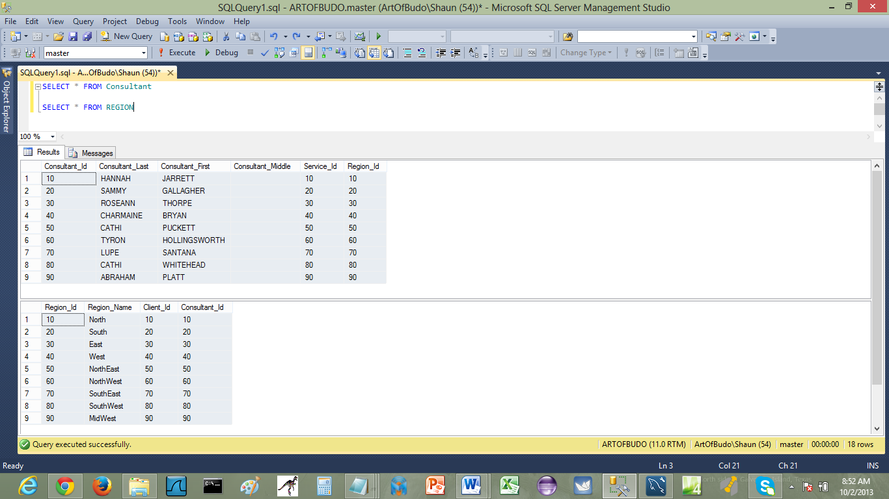

**/*SQL QUERY TO SELECT CONSULTANT IN A GIVEN REGION*/**

SELECT CONSULTANT.Consultant_Id,CONSULTANT.Consultant_Last,

CONSULTANT.Consultant_First, REGION.Region_Name

FROM CONSULTANT,REGION

WHERE REGION.Region_Id = '20' AND CONSULTANT.Region_Id= '20'

**View from above SQL Query**

|  |  |  |  |
| --- | --- | --- | --- |
| **Consultant_Id** | **Consultant_Last** | **Consultant_First** | **Region_Name** |
| 20 | SAMMY | GALLAGHER | South |

**SCREENSHOT OF VIEW FROM ABOVE SQL QUERY IN MICROSOFT SQL SERVER**

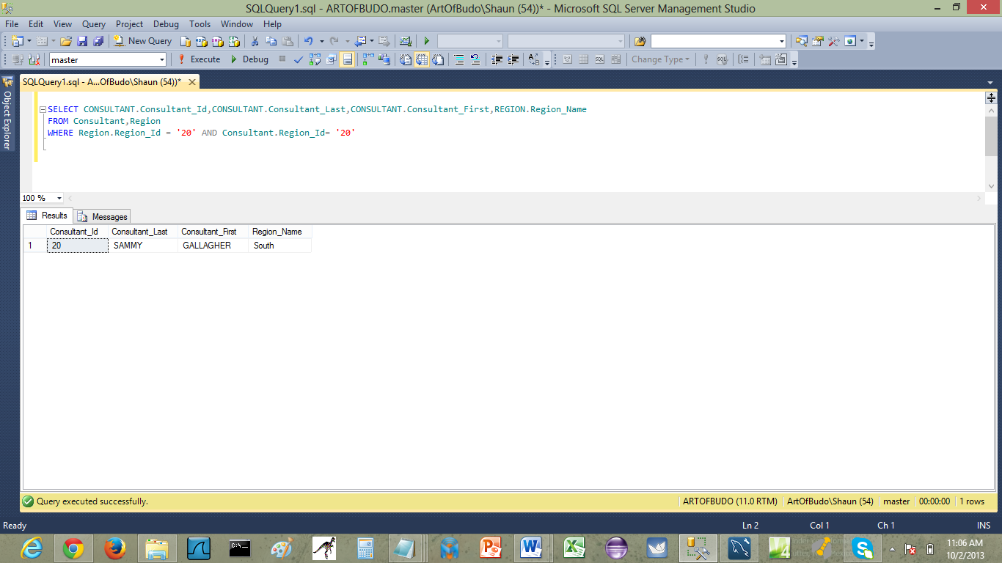

**Project 3(a) Create View of Normalized Tables 1**

**3NF VIEW OF SERVICE TABLE**

|  |  |  |  |
| --- | --- | --- | --- |
| **Service_Id** | **Service_Name** | **Consultant_Id** | **Contract_Id** |
| 10 | Web Designer | 10 | 10 |
| 20 | Network Infrastructure | 20 | 20 |
| 30 | Software Engineering | 30 | 30 |
| 40 | Database Development | 40 | 40 |
| 50 | Ethical Hacking | 50 | 50 |
| 60 | Java Programming | 60 | 60 |
| 70 | PHP Programming | 70 | 70 |
| 80 | Network Security | 80 | 80 |
| 90 | Distributed Systems | 90 | 90 |

**SCREENSHOT OF 3NF SERVICE TABLE**

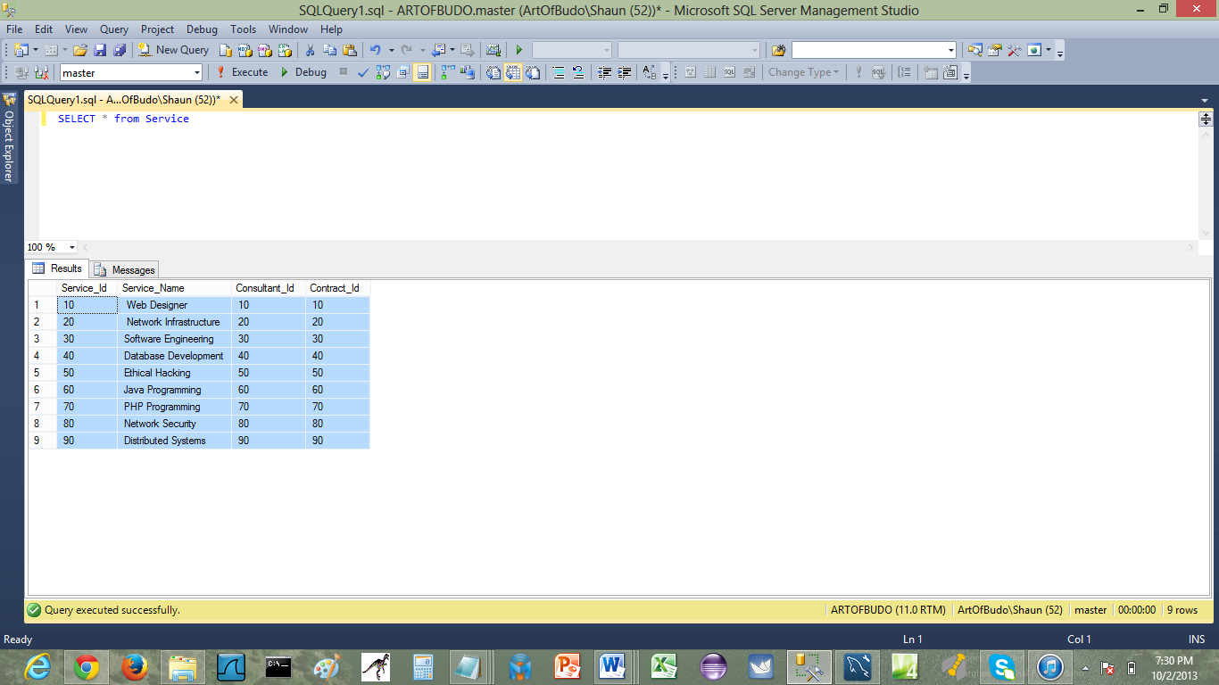

**3NF VIEW OF CLIENT TABLE**

|  |  |  |  |  |  |
| --- | --- | --- | --- | --- | --- |
| **Client_Id** | **Client_Last** | **Client_First** | **Client_Middle** | **Contract_Id** | **Region_Id** |
| 10 | Lewis | Shaun | Cornell | 10 | 10 |
| 20 | Martin | James |  | 20 | 20 |
| 30 | Carlos | King | Laria | 30 | 30 |
| 40 | Stieben | Jorge |  | 40 | 40 |
| 50 | Banger | Jay | Escobar | 50 | 50 |
| 60 | Godiva | Chessey |  | 60 | 60 |
| 70 | Fitzgerald | Scott | Gerald | 70 | 70 |
| 80 | Cain | Abel |  | 80 | 80 |
| 90 | Nestallos | Finados | Givados | 90 | 90 |

**SCREENSHOT OF 3NF CLIENT TABLE**

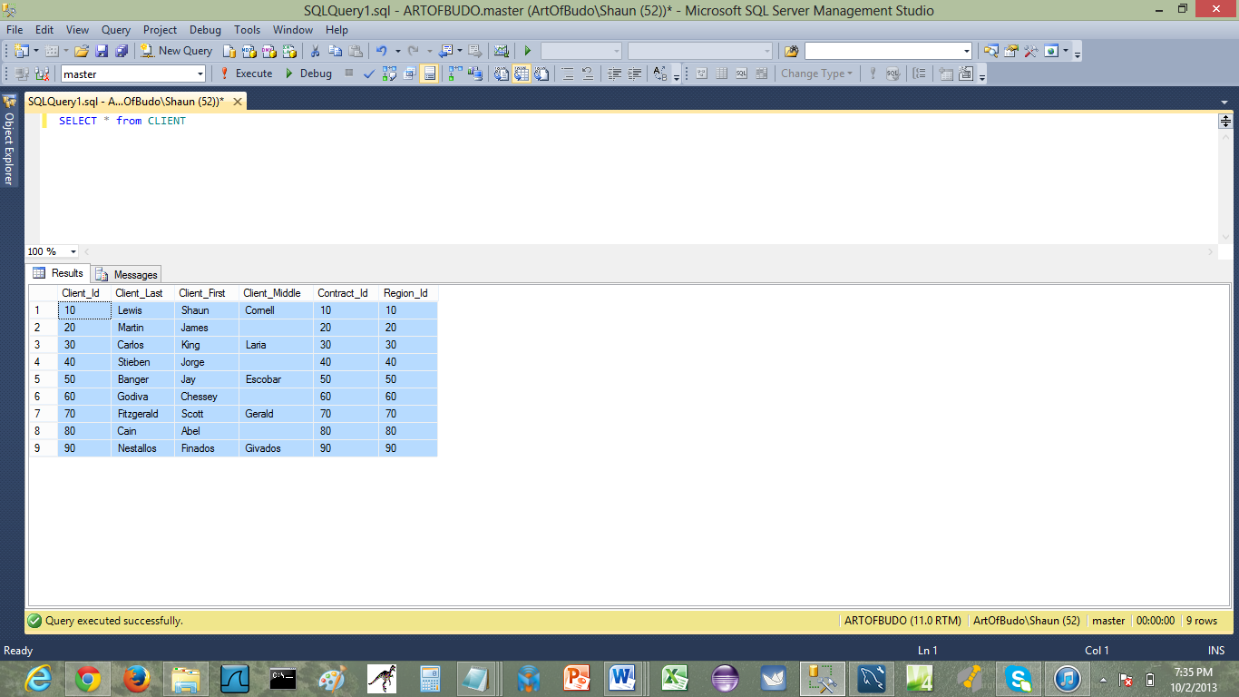

**3NF VIEW OF REGION TABLE**

|  |  |  |  |
| --- | --- | --- | --- |
| **Region_Id** | **Region_Name** | **Client_Id** | **Consultant_Id** |
| 10 | North | 10 | 10 |
| 20 | South | 20 | 20 |
| 30 | East | 30 | 30 |
| 40 | West | 40 | 40 |
| 50 | NorthEast | 50 | 50 |
| 60 | NorthWest | 60 | 60 |
| 70 | SouthEast | 70 | 70 |
| 80 | SouthWest | 80 | 80 |
| 90 | MidWest | 90 | 90 |

**SCREENSHOT OF 3NF REGION TABLE**

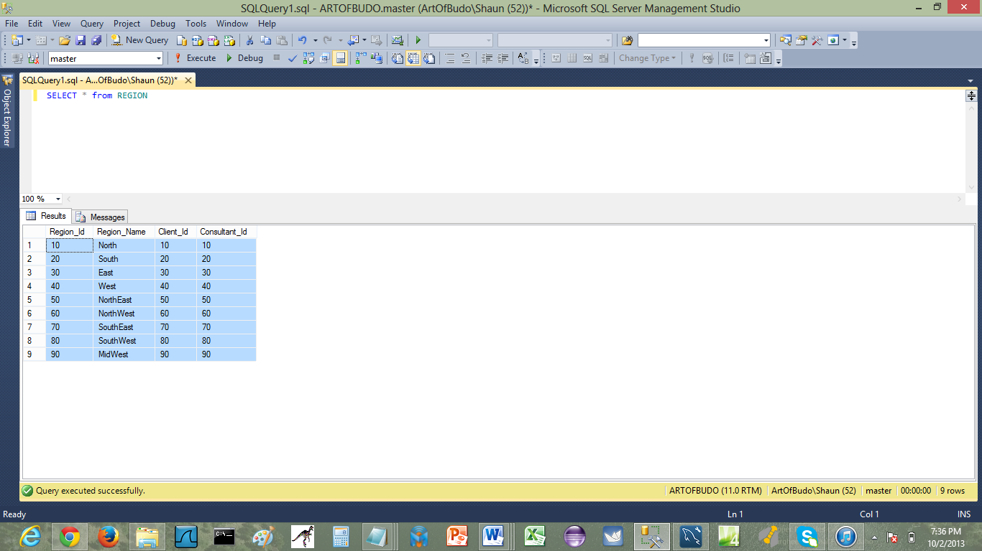

**3NF VIEW OF CONSULTANT TABLE**

|  |  |  |  |  |  |
| --- | --- | --- | --- | --- | --- |
| **Consultant_Id** | **Consultant_Last** | **Consultant_First** | **Consultant_Middle** | **Service_Id** | **Region_Id** |
| 10 | HANNAH | JARRETT | NULL | 10 | 10 |
| 20 | SAMMY | GALLAGHER | NULL | 20 | 20 |
| 30 | ROSEANN | THORPE | NULL | 30 | 30 |
| 40 | CHARMAINE | BRYAN | NULL | 40 | 40 |
| 50 | CATHI | PUCKETT | NULL | 50 | 50 |
| 60 | TYRON | HOLLINGSWORTH | NULL | 60 | 60 |
| 70 | LUPE | SANTANA | NULL | 70 | 70 |
| 80 | CATHI | WHITEHEAD | NULL | 80 | 80 |
| 90 | ABRAHAM | PLATT | NULL | 90 | 90 |

**SCREENSHOT OF 3NF CONSULTANT TABLE**

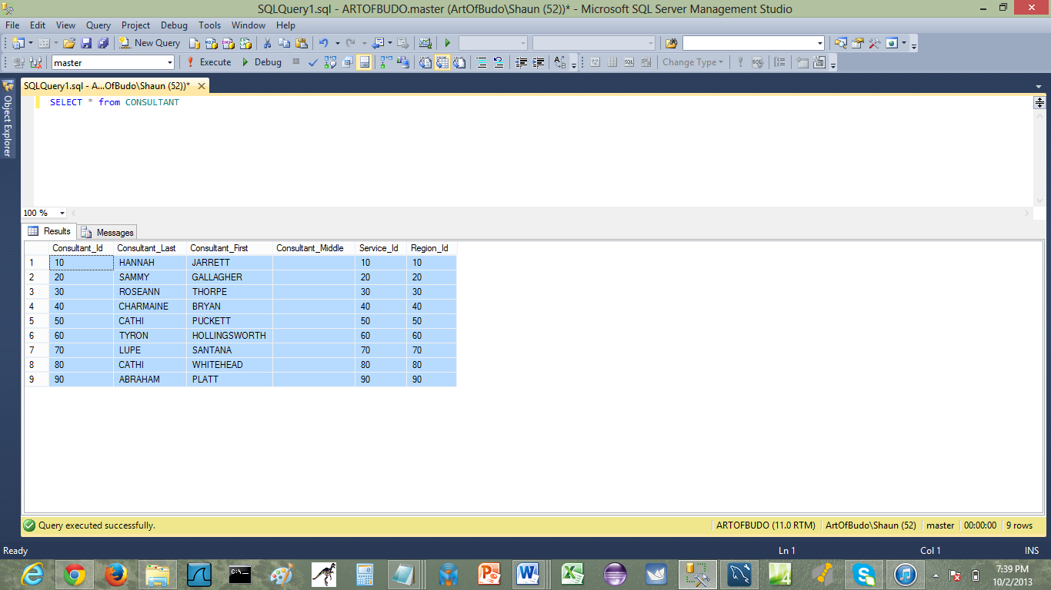

**3NF VIEW OF CONTRACT TABLE**

|  |  |  |  |  |  |
| --- | --- | --- | --- | --- | --- |
| **Contract_Id** | **Contract_Date** | **Contract_Amount** | **Consultant_Id** | **Service_Id** | **Client_Id** |
| 10 | 2012-12-03 | 344.97 | 10 | 10 | 10 |
| 20 | 2009-11-21 | 244.01 | 20 | 20 | 20 |
| 30 | 2011-10-11 | 295.01 | 30 | 30 | 30 |
| 40 | 2010-01-12 | 595.01 | 40 | 40 | 40 |
| 50 | 2012-09-22 | 659.01 | 50 | 50 | 50 |
| 60 | 2012-05-25 | 992.01 | 60 | 60 | 60 |
| 70 | 2012-10-11 | 300.01 | 70 | 70 | 70 |
| 80 | 2011-01-01 | 295.01 | 80 | 80 | 80 |
| 90 | 2011-11-12 | 995.01 | 90 | 90 | 90 |

**SCREENSHOT OF 3NF CONTRACT TABLE**

